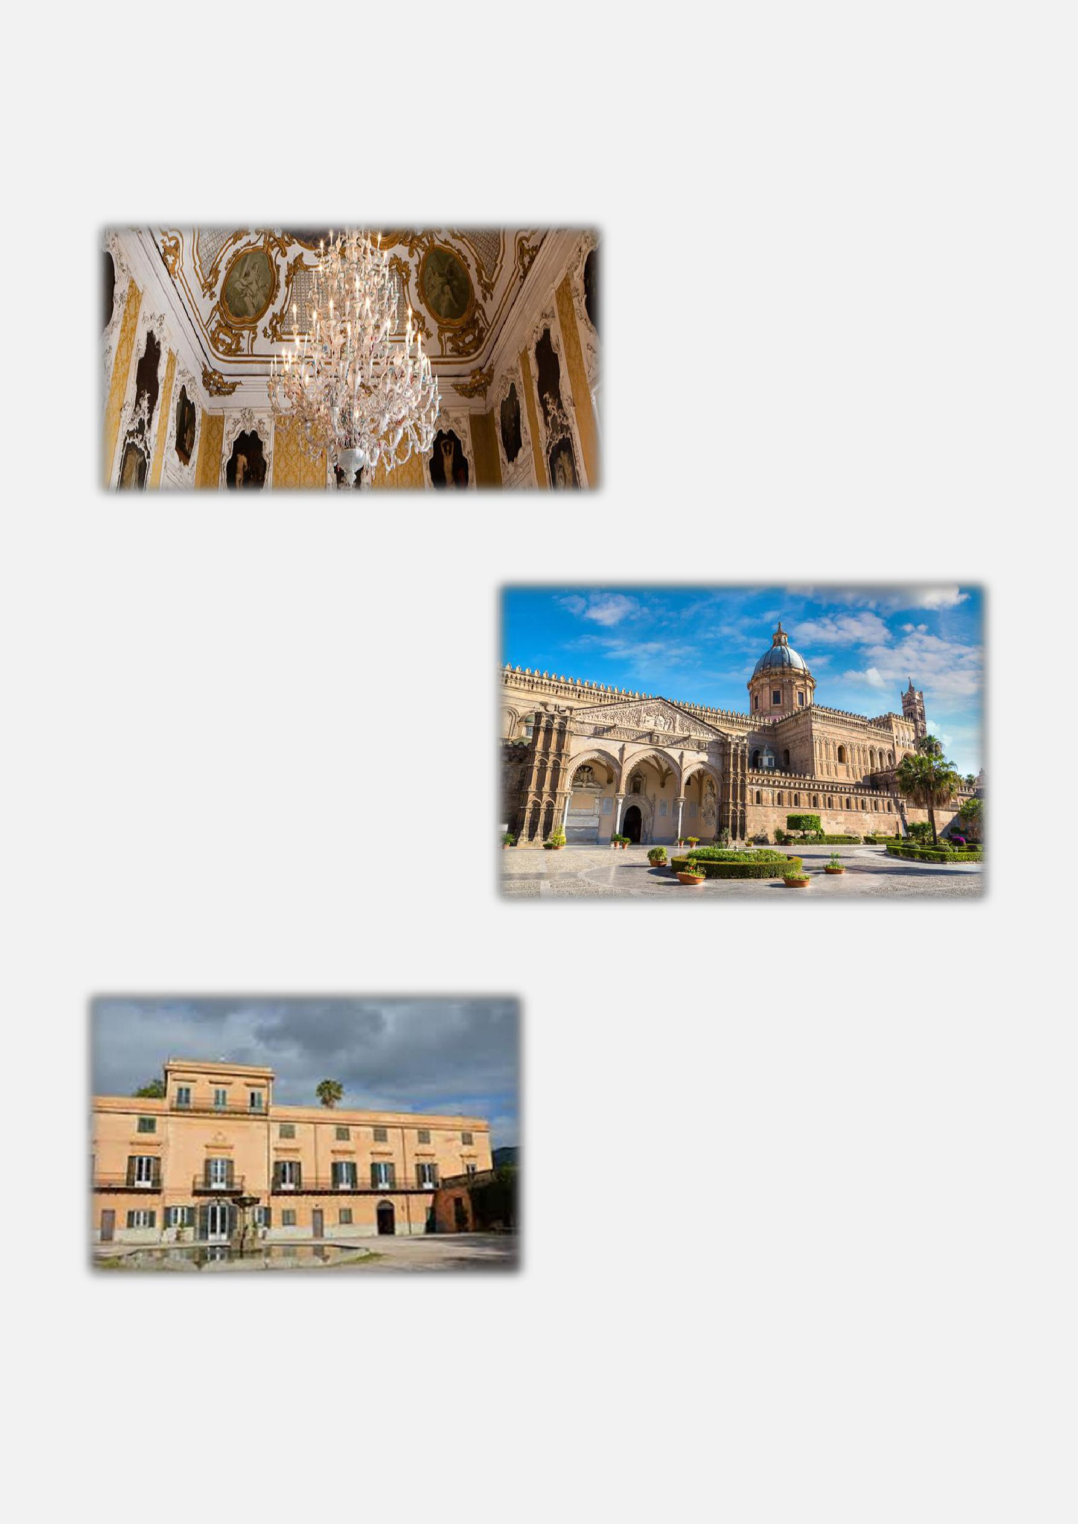
HOTEL FEDERICO ll **** – PALERMO (3 nights)

The Hotel Federico ll is located in Palermo City Centre, 15-minute walk from the harbour. It offers numerous dining opportunities and a panoramic roof garden where breakfast is served during summer. The Hotel is accessible by taxi (approximately €50.00 one way) or very comfortable bus (€6.00) every 30 minutes from the airport arriving at Piazza Castelnuovo, just 4 minutes’ walk to the Hotel. (400 meters).

January 16:

Arrival: Individual transfer and check in

(see airport information, above suggestions)
The Hotel Federico II Palermo 4*

http://www.hotelfedericopalermo.it/en/

19.30 Short walk to Palazzo Alliata di Pietratagliata (900 meters) for a private visit of the palace and a welcome cocktail with finger food in one of the beautiful rooms of the theatre, Regal Stage Room or Pompeian room.

Evening free.

January 17:

After breakfast at the hotel, we meet our local guide to depart for a walking tour of the City Centre.

Free time for lunch and individual sightseeing.

Afternoon, Annual General Meeting followed by an Allied workshop at the hotel. Free time for spouses and guests. Evening free for Regional Get-togethers.

January 18:

After breakfast at the hotel, we meet our local guide and driver to depart for a half day excursion to Monreale to discover the beauty of this small village.

In Monreale we will visit the Cathedral and
the Cloister typical of the Arabic-Norman culture.
Free Lunch and Free time in the afternoon.

19.30 Transfer by coach to Villa Chiaramonte Bordonaro for our Farewell Dinner to celebrate and close the annual meeting.

January 19:

After breakfast at the Hotel, individual transfers for the members leaving today.

POST TOUR, ROMANO PALACE HOTEL ***** EAST SICILY (3/4 nights) For members and guests joining the post tour 4 nights/5 days to East Sicily, we meet our Tour Manager and Coach Driver and depart to Catania. Along the route we will first stop in Piazza Armerina to discover the beautiful Villa Romana del Casale and its huge mosaics.

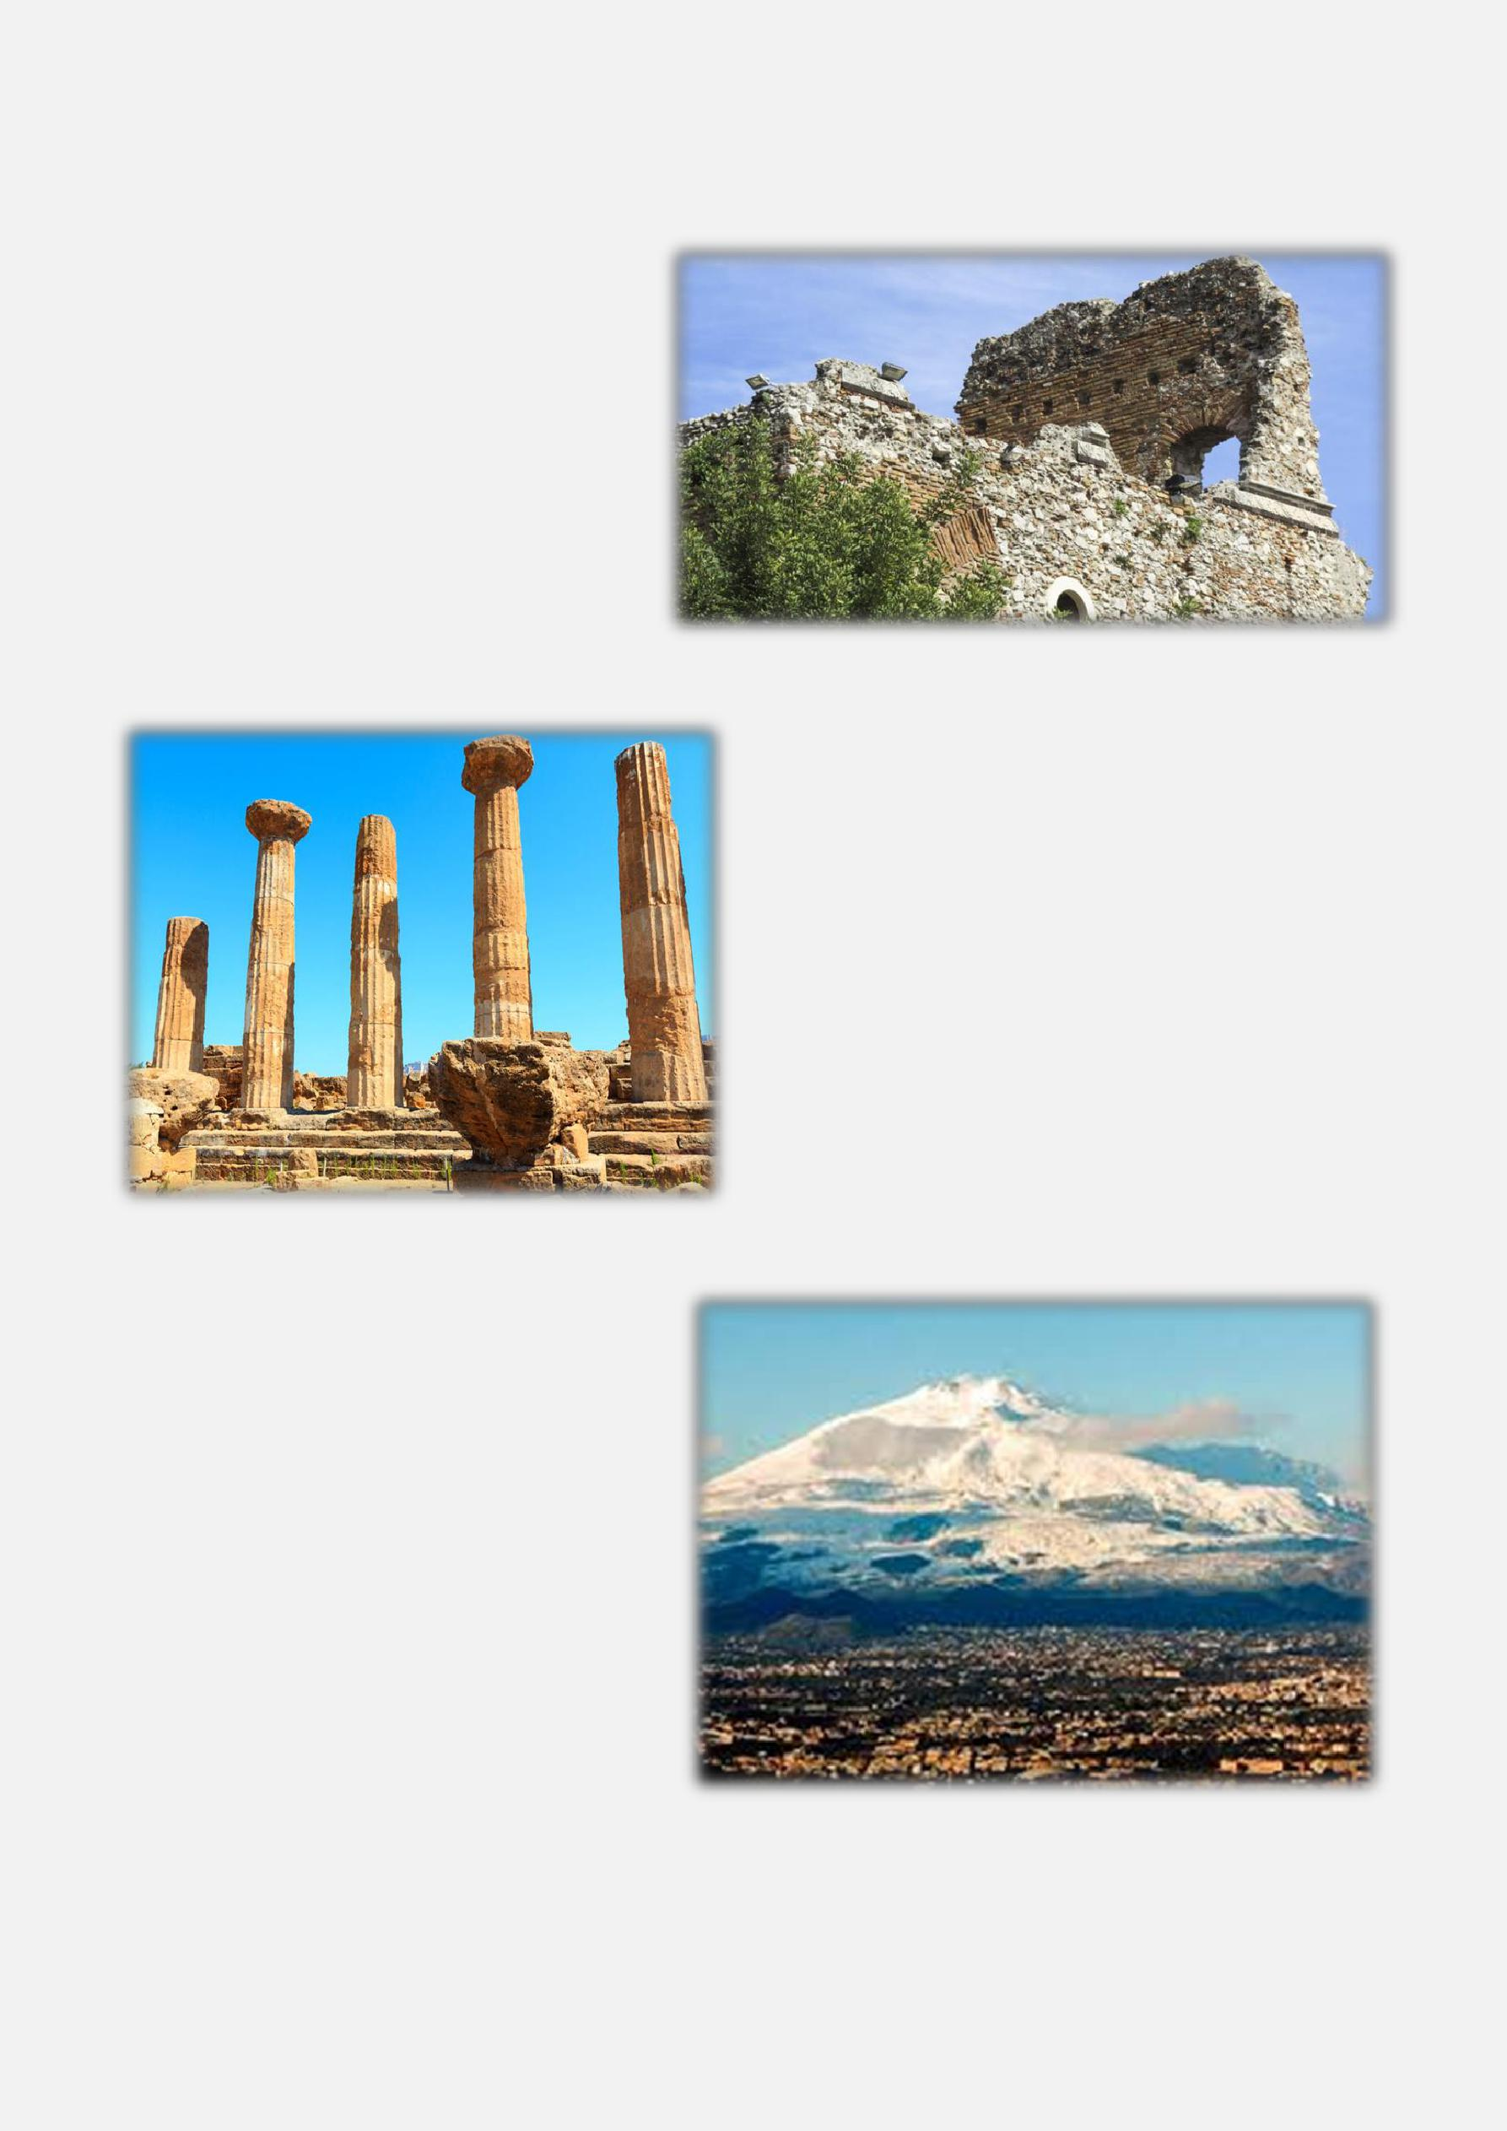
Lunch in a typical farmhouse in the surroundings and continue to Catania. Arrival to the Hotel Romano Palace 5* http://www.romanopalace.it/en/ and check in. Dinner at the hotel and overnight.

January 20:

After breakfast at the hotel we meet our Tour Manager and depart for Taormina for a visit of this beautiful village with its amazing view of Mount Etna and Mazzarò bay. Enjoy free time to visit the Greek Theatre and to stroll among the romantic narrow streets.

Free lunch, and transfer to Savoca for a visit of the unique, small village, setting of “The Godfather”.

Dinner at a restaurant and overnight.

January 21:

After breakfast at the hotel, we meet our Tour Manager and depart to Syracuse to discover what was once the most important city in the Mediterranean, heavily influenced by the Greeks. We arrive at the archaeological park and visit the Greek Theatre with our local guide. The visit will also include: Dionysius’s Ear, the Latomie and the Roman Amphitheatre. Later, we transfer to Ortigia to visit the historical centre of Syracuse. Ortigia is the heart of Syracuse, connected with the modern city by a spectacular bridge. Here you will visit the Temple of Apollo, the Cathedral (Temple of Minerva) and the Fountain of Aretusa. Enjoy lunch in a local restaurant and free time in the afternoon to spend in the city centre. Return to Catania. Evening free and overnight at the hotel.

January 22:

After breakfast at the hotel, we meet our Tour Manager and depart for Mount Etna to discover the highest active volcano in Europe. Our arrival takes us to 1800 meters and from here, there is a possibility to climb up to 2800 meters by cable car and Unimog 4x4. (The climb up is optional €65.00 per person – for the people that don’t want to go it will be possible to walk along the dormant crater of Silvestri).

After the visit, we have a farewell lunch in a local winery at the foot of Mount Etna, before we depart to Palermo via Catania. Depending on return flights, either overnight in Catania at the Romano Palace or Palermo at the hotel Federico ll and a free evening ready for departure flights.

January 23:

After breakfast at the hotel, we are free to transfer to Palermo airport for our return flight.

IATM, International Weekend and AGM, Palermo, Sicily – 16/19 January 2019.

Post Tour, Catania/Palermo 19/ 23 January 2019.

Mr/Ms/Mrs: Surname: ________________ |  |  | Forename: ___________
Street/Nº: |  |  | City: ________________
Post Code: _ | Country: _______________
Telephone: _________________ |  | Fax: _______________ | e-mail: ____________________________

Company (Allied & Associate Members): _________________________________________________________

Sharing with (Name): _____________ |  |  |  |  |  |  |  |  |  |  |  |  | (if applicable)
Category: Active |  | Passive |  | Allied |  | Associate | Affiliate |  | First time attendee
IATM Region (please select):
Americas | Belgium |  |  | British |  | Central European |  |  | French | Israeli |  |  |  |  | Italian
Netherlands | Nordic |  | Pacific |  | Portuguese |  | Spanish |  | Taiwanese
 |  | Fee |  |  |  | Before |  |  | On or After |  |  | No of |  |  | Total
 |  |  |  |  |  |  |  |  |  |  |  | pax
 |  |  |  |  |  | 17/12/2018 |  |  | 17/12/2018
All Members (Active/Allied/Associate) |  |  |  |  |  | €460.00 |  |  | € 510
Guest (must be sponsored by a member) |  |  |  |  |  | €510.00 |  |  | € 560
Spouse/Partner (each member may bring their spouse/partner at the member’s rate)
Single supplement |  |  |  |  |  | €90.00
POST TOUR Catania |  |  |  |  |  | €540.00
Guest rate |  |  |  |  |  | €590.00
Single Supplement |  |  |  |  |  | €120.00
Pre-night | Palermo |   Twin/single |  |  | 100.00 | - Date
Post-night Palermo  Twin/single |  |  |  |  | 100.00 | -Date
If booking a shared room please indicate whether you require twin beds or a double bed
 |  |  |  |  |  |  |  |  |  | TOTAL

I have read, understood and accept the booking conditions and cancellation charges. I realise that it is my own responsibility to ensure that adequate health and cancellation insurance cover has been arranged for myself and any other person(s) named on this booking form.

Signed: ____________________________________________________ |  |  | Date: ____________________________
 | BANK DETAILS: ULISSE VIAGGI E TURISMO s.r.l.
 | Account N. 300682349
 | UNICREDIT Via Libertà, 185/a - Palermo
 | Abi Code 02008 | Cab Code 04638

IBAN Code: IT 43 E 02008 04638 000300682349
SWIFT: UNCRITM1856

A booking will be made ONLY on receipt of full payment

booking form to nadia@ulissetouroperator.com (or) Fax: [..34] (91) 626 8542

